Packing Paintings for Galleries & Shows
By Susan Blackwood
http://www.oilpaintersofamerica.com
Here is an excellent way to pack your paintings for shipping. It is reusable, relatively inexpensive and extremely sturdy. Your galleries will love it and so will OPA and other shows. No matter how you pack, please do not use “popcorn” packing material. Galleries and shows do not like it at all.
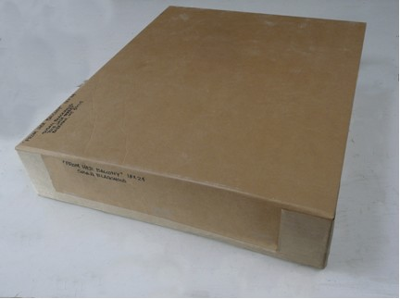
Here are the Materials that you will need:
- Plastic sheet or a large plastic bag to wrap the painting
- Corrugated cardboard - can be purchased or you can use cardboard from large boxes like mattress boxes and appliance boxes ( free at stores )
- Construction Styrofoam (comes in various thicknesses from 1" to 2½" - the larger the painting the thicker the Styrofoam (purchase from lumbar yards)
- Plastic super strength packing tape
- Reinforced brown paper packing tape (optional)
- Water and sponge for wetting the brown packing tape
- Knife with a thin long blade
- Measuring tape
- Long steel ruler or straight edge for marking, cutting and scoring lines.
- Marker for making lines
- Screwdriver for scoring lines
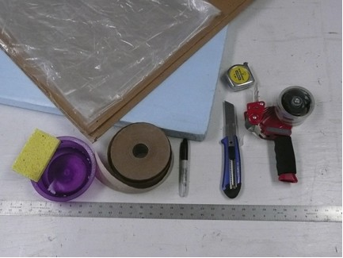
Step 1: Wrap the painting in plastic.
This protects the frame’s finish from rubbing off while it is in transit. It also keeps packing particles off of the painting.
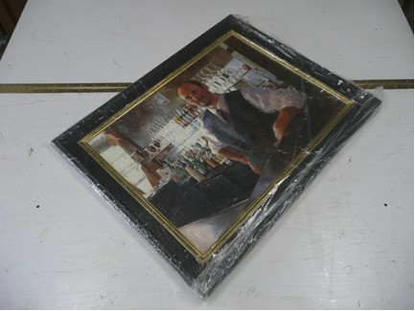
Step 2: Measure the outer dimension of the frame.
In this example a 24" x 30" painting with a 4" frame width makes the outer dimensions 32" x 38". Now add to that dimension the width of the Styrofoam that you are using. In this example we are using 2 inch Styrofoam. Therefore, make the bottom Styrofoam layer measurement 2 inches bigger on each side than the outside measurement of the frame. The measurement is now 36" x 42".
Mark your lines (36"x 42") on the Styrofoam with a marker.
Step 3: Next using the long bladed knife cut the Styrofoam.
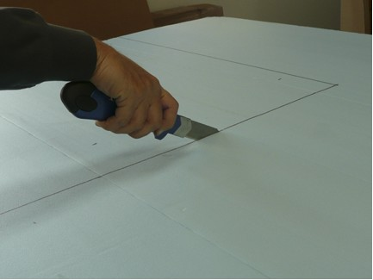
Step 4: Center the painting onto the Styrofoam
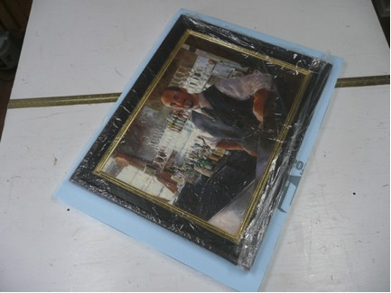
Step 5: Cut strips to fit all around the frame. Be sure the strips are the depth of the frame.
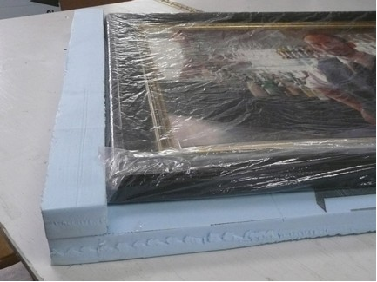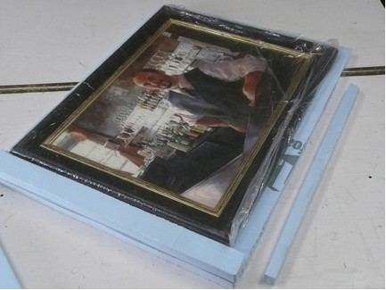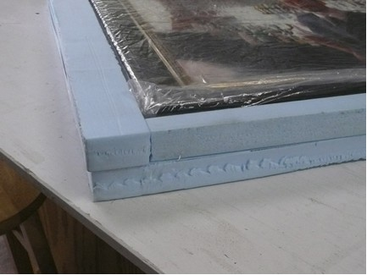
Step 6: Mark and cut another piece of styrofoam to the same size as the bottom piece
(36" x 24" in our example), tape the layers together. You have just created a sturdy interior package for your painting, but it needs an outside layer of cardboard before you ship it.
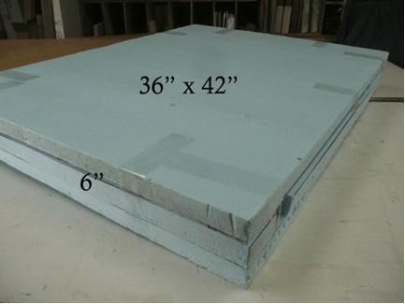
To encase your Styrofoam package you have the following options:
Option 1: Slide the Styrofoam package into an existing cardboard box (if you have one); cut down the box to fit or fill in the gaps with bubble wrap.
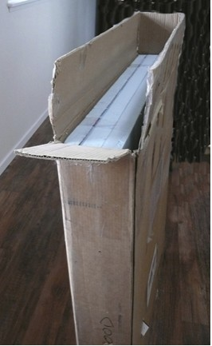
Option 2: Making a cardboard “skin” for the Styrofoam package.
Step 7: Making the bottom of the cardboard skin.
Mark the cardboard the size of the Styrofoam package adding the height of the Styrofoam package on each side.
For example our Styrofoam package measures 6 inches deep. So we added 6 inches to each side of the outside measurement making our cardboard piece 48 x 54.
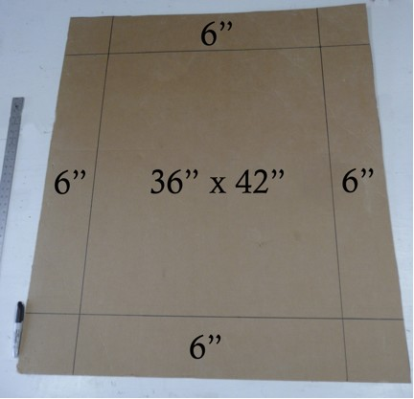
Step 8: Score (denting cardboard but not cutting it) the lines with the side of a screwdriver so the cardboard folds on the lines.
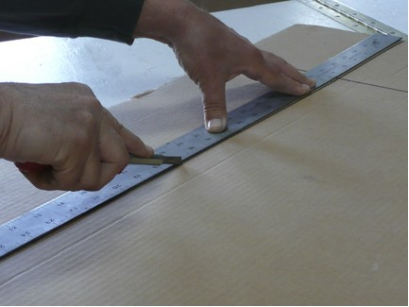
Step 9: Fold the sides up
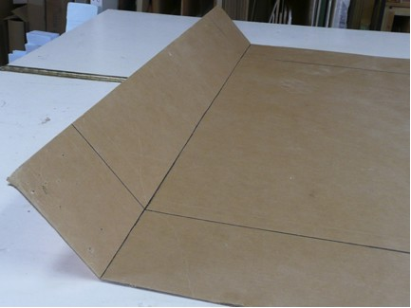
Step 10: Using the knife cut one line only in each corner.
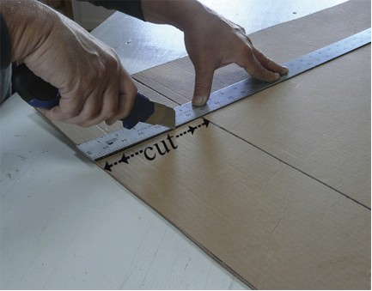
Step 11: Position the Styrofoam package into the center of the cardboard.
Put the name of the painting, the size and your name on the side and top of the Styrofoam for easy identification.
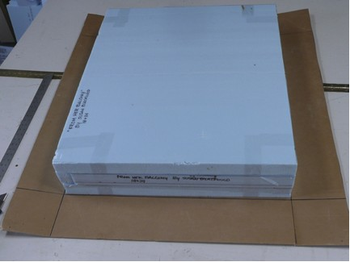
Step 12: Bring the sides up, folding the wings around the corner.
Tape the corners.
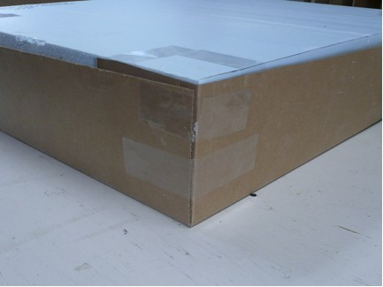
Step 13: Making the top of the cardboard box:
Repeat steps 7 through 10, measuring the outside of the newly constructed cardboard box. Cut the new piece of cardboard about 1/8th inch larger on each side. Measure the height of the cardboard box and add 1/8th inch to it. Draw lines, score, and cut one line in each corner.
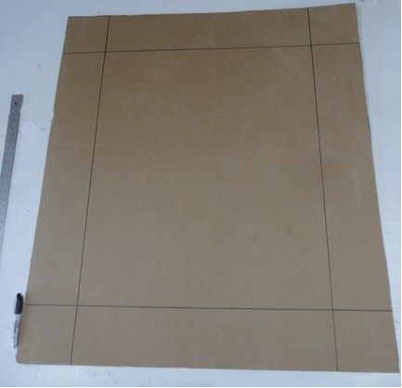
Step 14: Place the cardboard box upside down in the center of the cardboard
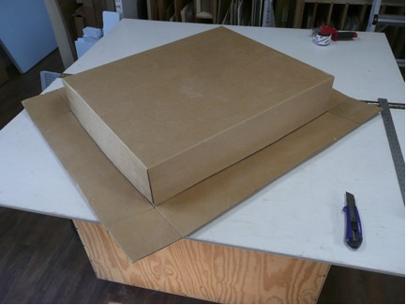
Step 15: Bring the sides up, folding the wings around the corner.
Tape the corners.
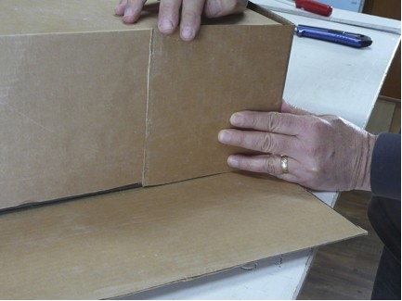
Step 16: Secure the sides with plastic packing tape.
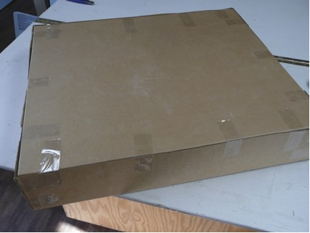
Step 17: Reinforce the corners and open edges of the box with brown paper reinforced packing tape.
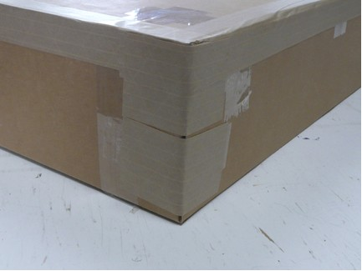
Step 18: Turn the cardboard box over. Put the title of the painting, size and your name on the side and the top, along with your return address. This makes it easier for a show/gallery to find your box in their storage and get your painting back to you safely in the correct box.
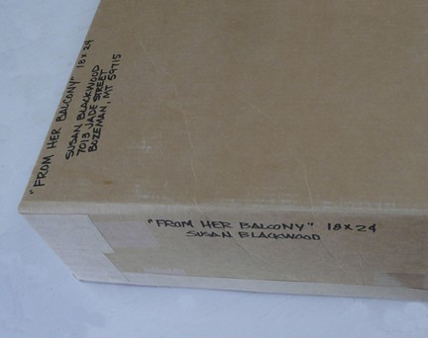
Once you get the hang of it, you should be able to build this packing system in an hour or less.

